Ubiquitous Cloud Computing For Smart home

Introduction:

*“A smart home is a home that incorporates advanced automation systems to provide inhabitants with sophisticated monitoring and control.”*

The rapid development in growth of smart devices and its connection network has given birth to

Internet of things and at the theheart of it lies the connection of smart homes . A collection of smart homes lead to smart environment . What makes the data analysis of  smart home so compelling to be studied ? Why cloud is considered to be next big thing for framework of smart home and thus essential common point of Internet of things ? What else are the possible aspects that cloud can provide for core as well as value added service to Smart Home ? This paper presents talks through all this challenges and discusses the impactful role of cloud in development of smart home and thus playing essential role in smart environment development.The curiousness towards the data generated by the smart home is a key aspect of our paper . Due to  recent advance of new quality sensors and interconnected concept of smart home has led to a widespread connection of smart home . The data produced is not only “BIG” but it is also a “meaningful” data , which introduces new challenges of not only data storage but also of how data is processed and accessed. One of the key aspect that we had looked into is not only this data is meaningful but it is also very “sensitive” data . The data generated from the smart home is a very confidential data . Though the analysis of such data can have vast applications as value added  services to inhabitants and even detection of anomaly , it is absolutely essential to maintain confidentiality and Integrity of data extracted from smart home.Our paper here also discusses how cloud can serve as a brain for improving decision making from insight of data analysis . For example, the data analysis of smart home is now being currently used by medical practitioners to study behavioral patterns shown by patients of certain diseases, the analysis of such data is crucial but the decision making on such data has to be quick to respond to patients need.The better part of using cloud computing is it makes the utility of  data from smart home to be Ubiquitous. Providing on demand service and multiple platform for accessing the data . As we see the fruitful meet of cloud and smart homes , there are certain challenges which need to be addressed. One of them is design of a proper cloud architecture , we have gone through various cloud architecture and the one we have chose to discuss in this paper is an architecture[1] which incorporates all essential characteristics of cloud . Some other challenges that may arise due to this collaboration of cloud and smart homes is integration of devices,smart homes to cloud , security of data to be processed by cloud and complexity of deployment of cloud.Other challenges includes QoS (Quality of Service ) as provided by cloud, as cloud is seen here to be a utility based service model.

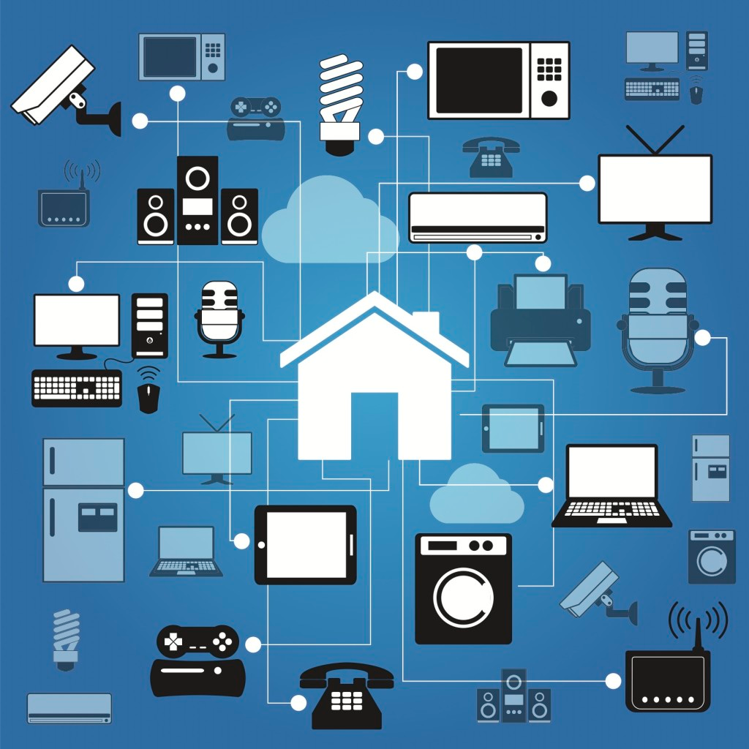

Characteristics Of Cloud As Requirement of Smart Home :

First characteristic of  Cloud Computing is **On-Demand Self Service** which means it’s there when you need it without human help or interference. Once something is set up in the cloud with the right configuration, the cloud takes care of everything else like physical storage management. It manages all the different resources if properly configured.In our scenario, if configured properly the cloud will manage the continuous data flow, the increasing data by allocating necessary storage elements, perform the necessary analysis and return some result back to the user on a timely basis.

The second characteristic of  Cloud Computing is **Broad Network Access** which means a lot of connectivity options. Cloud computing resources can be access through a device that can access network or have internet connection such as tablets, mobile devices and laptops. With the help of IoT, cloud computing can be accessed with any device that have network access and will make the user easier to access with the devices that they mostly like. With help of cloud, smart home  computing becomes really accessible since the devices/sensors can send their data to the cloud/receive data with the help of any gateway device that is connected to the internet. Also the smart home user can monitor his smart home/get some meaningful analytic through any device such as a smartphone,tablet etc. with a decent internet connection.

Furthermore, the third characteristic is **Resource Pooling** which means sharing of resources,services or bandwidth without the customer knowing about this shared environment. It can make the user become easier to access in what they want and when they have a free time to access. In the smart home context, there are many smart homes connected to the same cloud. Each of these smart homes share the same service for the protocol transfer/data storage etc.but the customer is not aware of this shared environment.

Moreover, the fourth characteristics is **Rapid Elasticity** which means that you get what you need. You can be easily and quickly to edit your software features and to add or remove user inside your cloud computing. This characteristic will empower Smart home by providing elastic computing power, storage and networking .

Lastly, the fifth character of the Cloud Computing is **Measured Service** which means that you get what you pay for. This cloud computing will measure your usage about their service such as storage, processing, bandwidth and active user accounts inside your cloud computing. The meter will increase as how much your usage.

REQUIREMENTS OF CLOUD SMART HOME PLATFORM

This section of our paper discusses the need of cloud for platform as a service . When looking at the cloud for platform as a service it is quintessential to look over the fact that the data provided to server or any application be as secure as possible . Because by nature the data generated by users in smart home is a highly personalised data. Looking over this very nature of data generated by cloud , many researchers have chose to call data generated by smart home to be very sensitive. Data handling of such sensitive data requires special attention towards maintaining confidentiality and integrity of data . The biggest challenge we have realised here was looking at a cloud model which could be easily deployed with shared resources without compromising the data confidentiality and security .

Another big reason for using cloud as platform was its service oriented nature as described by in their research paper [1]”A platform as a service for smart home” ,there are two most important types of services which a cloud platform could provide and all other services can be described as a part of  it . These are

**i. )Services for controlling the Smart Home**

Services for controlling smart home includes the services that a cloud can provide for better management of Smart home . For example , automation systems,monitoring systems and alarm systems in Smart home . Cloud can prove a very efficient module for providing these services as one complete Infrastructure . Also , the scenario of interconnected smart homes call for better services among the service providers and and service providers and clients . As per our understanding cloud here could play crucial role by providing better SLA between client to service providers and between different service providers , creating a complete Ubiquitous model at service level.

**ii.) Value Added Services**

Value added services can be defined as services which though not as essential in control of smart home are essential for improving the quality of inhabitants. For example suggestion systems and prediction models for better improvement in life of inhabitants . Recently there has been a great upsurge in research field for this type of services provided by smart home. A term known as “Active” living has been coined , which is defined as improvement in living standards of inhabitants based on various prediction models concerning the activities performed by the inhabitant of smart home. Cluster of smart devices need to be interconnected to clients for this service to be achieved, the idea here is to make data analysis as fast as possible and as readily available as possible for better improvement in SLA.

                                   We like to think that there are four levels of component in smart home i.e a inhabitant who is the basically consumer of the services , manufacturers of devices interconnected to smart home , service providers apart from that there are developers and researchers . We want to include researchers and developers in this component level description because it is worth noting that data produced by smart home is nothing if not used for providing insight for better improvement of life of inhabitant.

Proposed Architecture of Cloud[1]

As per the  proposed Architecture of Cloud  as given by Boyun Eom, Choonhwa Lee, Changwoo Yoon, Hyunwoo Lee, and Won Ryu in their research paper “A Platform as a Service for Smart Home “ there are four main parts in this  framework ; a real home gateway, a virtual home gateway, a smart home service platform, and smart screen devices. Clients might need only user interface to request a service to a cloud server, and thin or zero clients are easily found these days. The figure below depicts overall structure of our framework. A. Real Home Gateway and Virtual Home Gateway  The role of a typical home gateway is divided into two in our framework. A Real Home Gateway (RHG) plays a role of relaying data from home appliances and devices to the cloud. The other gateway, Virtual Home Gateway (VHG), on the cloud side takes care of rest roles of the conventional home gateway, as well as new additions. In a cloud computing environment, computing resources are abundant and most operations are performed on servers on clouds, and upgrading software and provisioning service become easier. By our approach which integrates smart homes into cloud computing environments, a real home gateway or smart screen devices for the purpose of user interface can be a client which requests services to servers on clouds. Therefore, minimal functionalities like relaying data are left to a real home gateway in our framework design. Once the Real Home Gateway receives data from home devices such as sensors, it sends these to a Virtual Home Gateway on cloud. A Virtual Home Gateway, then, parses received data and passes the results for making a decision on the sensitivity level of data. A VHG converts control-commands for each device when necessary. The converted commands are sent to a RHG and delivered to the device to control. B. Smart Home Platform  Proposed smart home platform has a number of components to meet the requirements as defined: Personal/Home Data Manager, Device Manager, User Manager, Log Manager, Metering & Billing Manager, Security Manager, and Service Manager.

Figure for  Platform as a service for smart homes:

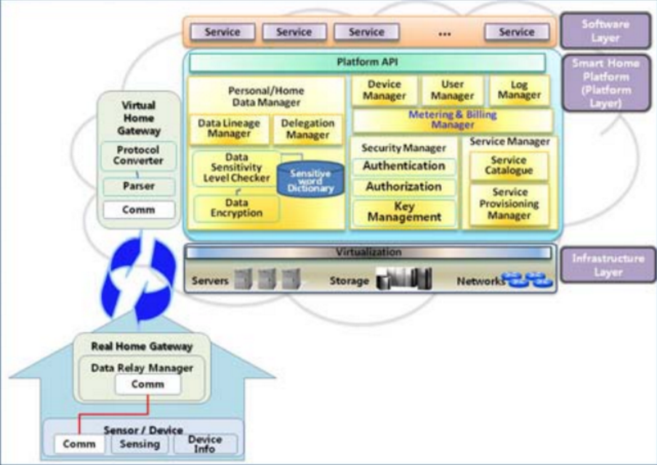

i) **Personal/Home Data Manager** is a component for protecting personal information. It decides data sensitivity level by checking parsed data from a virtual home gateway. For the context-aware process, Personal/Home Data Manager uses a dictionary containing keywords for sensitivity and encrypts sensitive data before stored in cloud storage [2]. Data Lineage Manager in Personal/Home data manager watches activities towards stored data. It records every data access or history on data such that where it is from at what time, who accessed data, and when and where it is copied to. Monitoring data access, which is one of requirements from the smart home owners for value-added services, can be resolved by Data Lineage Manager. Delegation Manager is provided for delegation functionality. If smart home owners want to share certain data with others, or if they want to use a service which requires their personal data, then he or she can give permissions to others or other services.

**ii) Device Manager** creates virtual devices which are mapped to real devices at smart home and provides user interface for controlling and monitoring those devices. Moving operations for managing smart homes to cloud results in better flexibility in upgrading software, which is one of the prominent advantages in cloud computing service. It also manages device information such as device type, protocols, IP address, and etc.

**iii) User Manager** plays role for managing user profiles such as user identification, family members, and devices a user owns.

i**v) Log Manager** keeps track of events or activities over the  system.

**v) Metering and Billing Manager** is one of the indispensable components for cloud computing which is a blend of “utility computing”. Smart home service platform integrates various services and the rate of a service can be varying. This component takes charge of service fees as well as the cost for cloud computing resource usage. It calculates total cost for smart home users who requested smart home services as well as service providers who consumed the platform for their service. y Security Manager plays three roles: authentication, authorization, and key management. For all services on the platform, SSO (Single Sign On) might be convenient for users, which is also resolved with SPML(Service Provisioning Markup Language). Depending on the type of contents or service, different cryptosystem might be needed for key management.

**vi) Service Manager:** Service Catalogue in service manager provides a list with all possible services to smart home owners. Every service needs to register its functions. Provisioning service is also one of the requirements for value-added services and Service Provisioning Manager in service manager automates all the steps required to manage users or system access entitlements or data relative to electronically published service.

Smart home platform deploys onto cloud infrastructure where resources are typically virtualized. Platform API helps the developers write programs to run on our platform. Most requirements for value-added services from software service providers are provided through Platform API and characteristics of data or data types can be provided, as well. Smart Home User Interface: Smart Device  In our framework, a real home gateway, a virtual home gateway, smart home user manager and device manager on smart home service platform, and smart home user interface take a part in performing the management functions for smart homes. Device Manager creates virtual devices which are mapped to real ones at smart homes and provides user interface to manage smart homes. Users can control, monitor, and make a schedule for those devices even outside the home through virtualized devices. When a user selects a control function of a certain device using the user interface, Device Manager creates a correspondent command and sends it to a VHG.

**Data For and By Smart Home**

**Fast Data**

The data generated from our smart homes is at a really large scale and unstructured[4]. Also this data is generated at a really high velocity, hence it becomes important to process this data at the rate at a fast pace and generate useful results out of it. Putting the generated data into a data warehouse and then processing is time consuming and becomes irrelevant by the time the insights are generated. Another reason it is not useful in our scenario is that most of our data is unstructured, as the opposite of the data warehouse structure. After the advent of Hadoop and Big Data Technologies has made it much more convenient to store and analyze such large unstructured data and perform analytics on it, but this is also slow and hence is known as late data analytic. What we need in our scenario is some technology that can process this high velocity unstructured data processing along with some rulebase and the incorporation of the previously stored data in real time. This is made possible through Fast Data developed by TIBCO. In this, the streaming data is sent through the Enterprise Service Bus to the Event Server . The event server has a set of rules that is considered while performing analytic on this real time data. This data can also be applied along with the previously obtained data from Hadoop and be sent in real time to the end user.

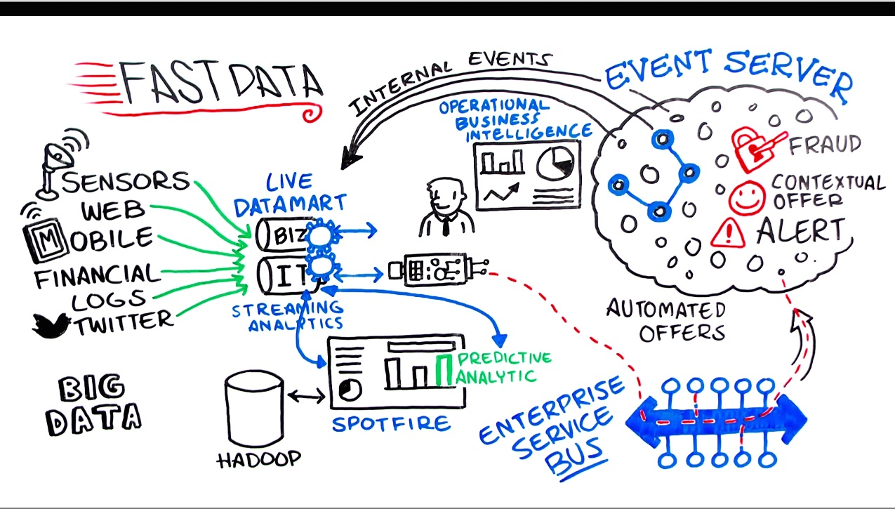

**Why Data Analysis of Smart home is of such importance ?**

In our paper we have talked much about the sensitivity of data generated by the smart home. But the prevalent question here is why is data analysis of smart home is so important? To answer this question we would like to focus our area of concern towards research based on behavioral analysis and pattern detection. Research based on data analysis of smart home has been proven very crucial in emergency handling and various prediction models . For example, data analysis of smart home is used in finding healthy life patterns also called “active” living. This is a logic based approach that concerns over issues regarding both space and time. The time stamped data can be reasoned over event occurrence (as event time) or on the basis of start and end time. Of which event time driven approach has shown a great promise. Each window of time is stamped based on event time and is then classified as an Activity. The time granularity here can be defined as infinite sequence of time points by marking starting and end points using watermark technique. Granulizing such data and applying Allen’s temporal reasoning to such sequence of data leads to finding of interesting patterns and anomaly detection systems. The granularity of data here can be continuous that is with no gaps or internal continuous with empty granules. Such reasoning over smart home data analysis have also opened new doors towards application of AI for smart home concerning activity detection and anomaly prevention schemes.

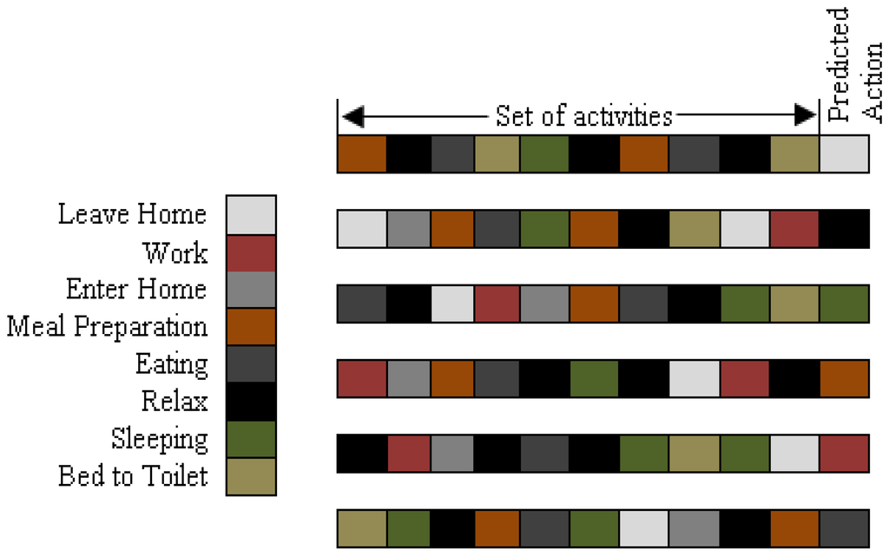

Figure giving a detail of Activity prediction[5]

Another crucial research as an application of data analysis of smart home is in field of medical science . There is an on going research on alzheimer's disease which is an acute case of memory loss. The data from smart home is analyzed over a period of time and a curve to show activity pattern is drawn , the inhabitants current activities are intersected with such a dynamic graph which leads to finding current state of inhabitant as well as time of occurrence of activity . Such analysis could then be used to find anomaly detection leading to alarm triggering . Another important issue here is that this analysis has to be fast , to have a corresponding fast reaction from the servers .

Data Analytics and Cloud

**i**)**Data Ownership**:

Data generated at smart homes are sensitive, and ownership issues are not always clear. Although a community center, healthcare provider or service providers could own the sensor and network devices, yet the data pertain to the residents of the homes. They should know what kind of data are collected, stored and shared. They should be able to stop the collection as well as ask for destruction of any stored records[3].The principle here used is delegation for security of data.

**ii) Data Transfer Transmission:**

Data transmission of the sensor data through unsecure networks should be protected. Confidentiality and integrity should be ensured for any data transfer. Confidentiality is securing sensitive data against a malicious user and integrity is preserving the truthfulness of the data. Cryptography or VPN techniques  are some of the commonly used approaches for securely transferring data.

**iii)Data Storage & Processing**

Data stored with personally identifiable information (or identifiers) in an external cluster is one of the important aspect for implementing cloud.The data produced by cloud is highly private data and it requires special care for storage of the data . Since this data has to be fast , the data storage module should be able to respond to dynamic queries for providing consistent data to the server . Another point is security of  personal information. Steps to protect privacy are to replace any personally identifiable information with randomized placeholders, introduce noise or swapping values while ensuring that statistical properties and data consistency are maintained . Another alternative approach is using generalization and suppression methods . The processing of smart home data should be independent of sensitive information[3].

**iv) Data Access**

Access to the system should be ensured through proper authentication and authorization. The system should be configurable to assign rights to execute analysis/mining jobs to appropriate users and access the generated results. Among many methods the role base access control has been widely accepted because of its simplicity, flexibility in capturing dynamic requirements and support for the principle of least privilege and efficient privilege management .

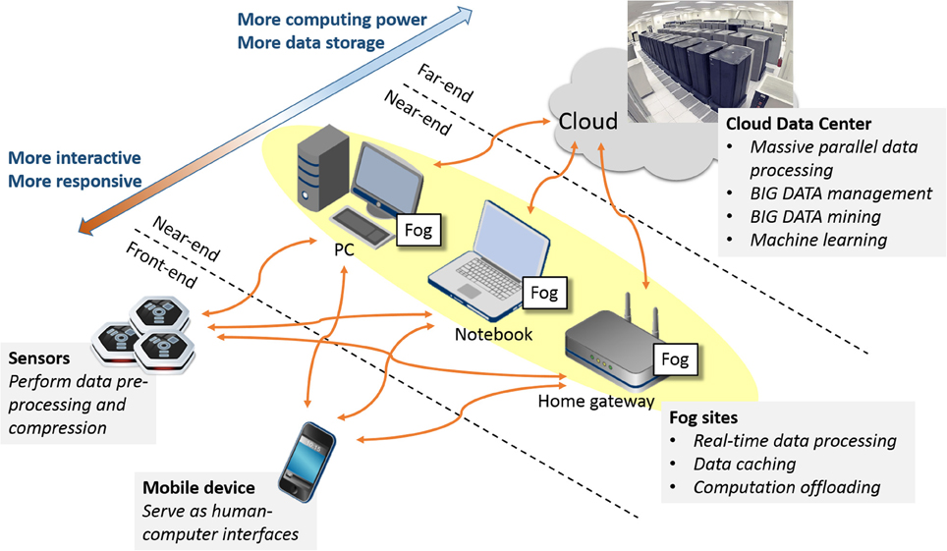

**Smart Home And Cloud Security**

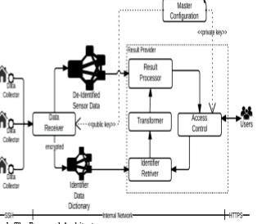

“Proposed Architecture[3] for securing data using cloud “

As we have made a constant theme in our research paper that data produced by smart home is very “sensitive” data i.e it is very personalised data and great security measures should be taken to make sure the data is being given into right hands . We feel cloud can be a very important aspect for providing security to data produced by smart home . Cloud can provide security to data based on following security measures that cloud provides :

**i) Delegation**

Delegation is process of exposing data securely in a shared environment[3]. Delegation is one of the very crucial aspect for data security in smart home and is often overlooked for its simplicity. The idea here is to make sure none of the data that the client doesn’t wants to share is available across other applications and users . It is very crucial to understand that delegation be applied before data is being store i.e a user should be able to grant permission to other services and users for how he wants to grant /deny permission for his data .

Here , it is worth noting that we want to propose an *automated delegation preference* security system which generates grant/deny tag for ultra-sensitive data. For example certain medical condition and diseases should only be disclosed to medical practitioners and hospitals and yet user should have privilege of denying his identity. Other small medical conditions  for example flu and cold can be easily disclosed. Basically the idea here that not all data is available across the platform for all the users and services .

Another module that we want to propose in security by delegation is time based delegation . Here, we want to propose that the data be available throughout the platform for over a period of time ,for example overlapping activity data can be presented for data analysis over certain period .

Cloud has a very unique approach for providing security as delegation , via shared preferences. Cloud is a two way communication system and requirement of user to be a part of infrastructure in cloud allows for delegation to be applied.

**ii)Encryption**

Security via encryption is to provide secured data across the platform when data is stored. Encryption security mechanism is applied to ensure data is safe from third party attacks . Cloud plays an important role for encryption in smart home because of its design . By design cloud ensures that the content provider has not unanimous control over the data , the form of mediation between the users and service providers is what makes cloud unique. Currently Cloud provides SHA 56 mechanism for enveloping keys for data across network , providing encryption mechanism. The point worth noting here is that cloud has capability of encrypting data across platform which does not hinders the availability of data . The discussion here seem vague if we don’t talk about cost of providing security via encryption . Encryption-Decryption of data increases the cost of platform significantly , thus here we want to propose that this mechanism is applied to only very sensitive data . For example , inhabitants personal preference and medical conditions be prefered for encryption rather than the log of activity of inhabitant .

**Conclusion**

Hence with the proposed Cloud based Architecture we are able to achieve scalability and flexibility in the sense that number of ubiquitous devices can be added dynamically to our smart home system and the architecture takes care of it all. Moreover, with cloud with we are availed with necessary tools to perform analytics on the data and sending back meaningful insights back to the user in a timely manner. Also we went through various behavioral prediction and anomaly detection algorithms all which can be intrinsically incorporated into our cloud based infrastructure.

**References**

[1]Boyun Eom, Choonhwa Lee, Changwoo Yoon, Hyunwoo Lee, and Won Ryu”A Platform as a Service for Smart Home “.

[2] L. Nhang, Q. Wu, and Y. Hu, “Hierarchical identity-based encryption with constant-size private keys,” ETRI Journal, vol. 34, no. 1, pp. 142-145, February 2012.

[3]Antorweep Chakravorty, Tomasz Wlodarczyk, Chunming Rong Department of Computer & Electrical Engineering University of Stavanger Stavanger, Norway {antorweep.chakravorty, tomasz.w.wlodarczyk, chunming.rong}@uis.no  2013 IEEE Security and Privacy Workshops “Privacy Preserving Data Analytics for Smart Homes”

[4] Fast Data Concept and Technology:<http://www.tibco.com/fastdata>

[5][Iram Fatima](http://www.mdpi.com/search?authors=Iram%20Fatima&orcid=), [Muhammad Fahim](http://www.mdpi.com/search?authors=Muhammad%20Fahim&orcid=), [Young-Koo Lee](http://www.mdpi.com/search?authors=Young-Koo%20Lee&orcid=)   and [Sungyoung Lee](http://www.mdpi.com/search?authors=Sungyoung%20Lee&orcid=) “A Unified Framework for Activity Recognition-Based Behavior Analysis and Action Prediction in Smart Homes”                                               [6] F. Daniel, F. Casati, P. Silveira, M. Verga, and M. Nalin, “Beyond health tracking: A personal health and lifestyle platform,” IEEE Internet Computing, vol. 15, no. 4, pp. 14-22, July-August 2011.                                                          [7]R.W. Baldwin, “Naming and Grouping Privileges to Simplify Security Management in Large Databases,” IEEE Symposium on Computer Security and Privacy, 1990 .